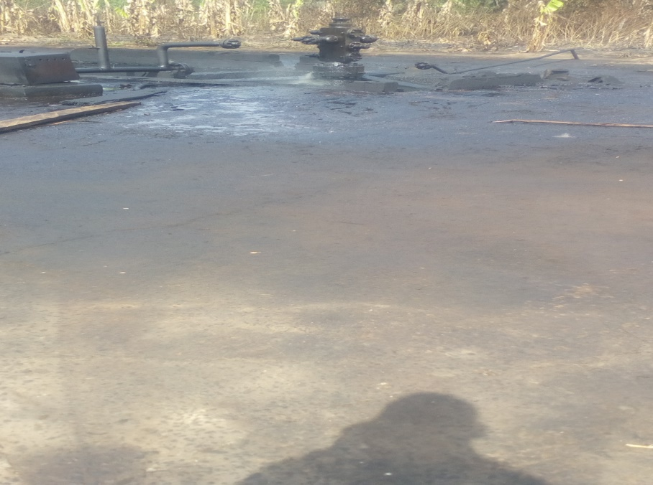

Leakage from ring gasket of wing valve damage as a result of fire caused by unknown person(s) from Umuoru 6T Well Head.
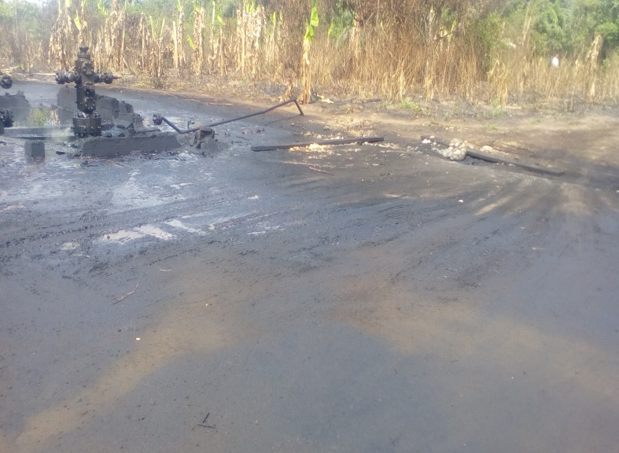

Impacted area around the spill point

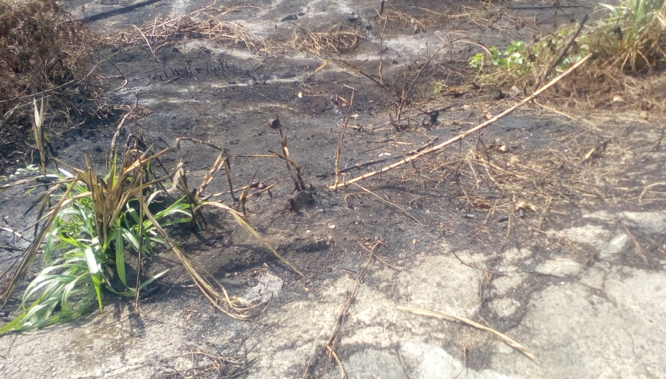
Impacted vegetation by (fire) incident
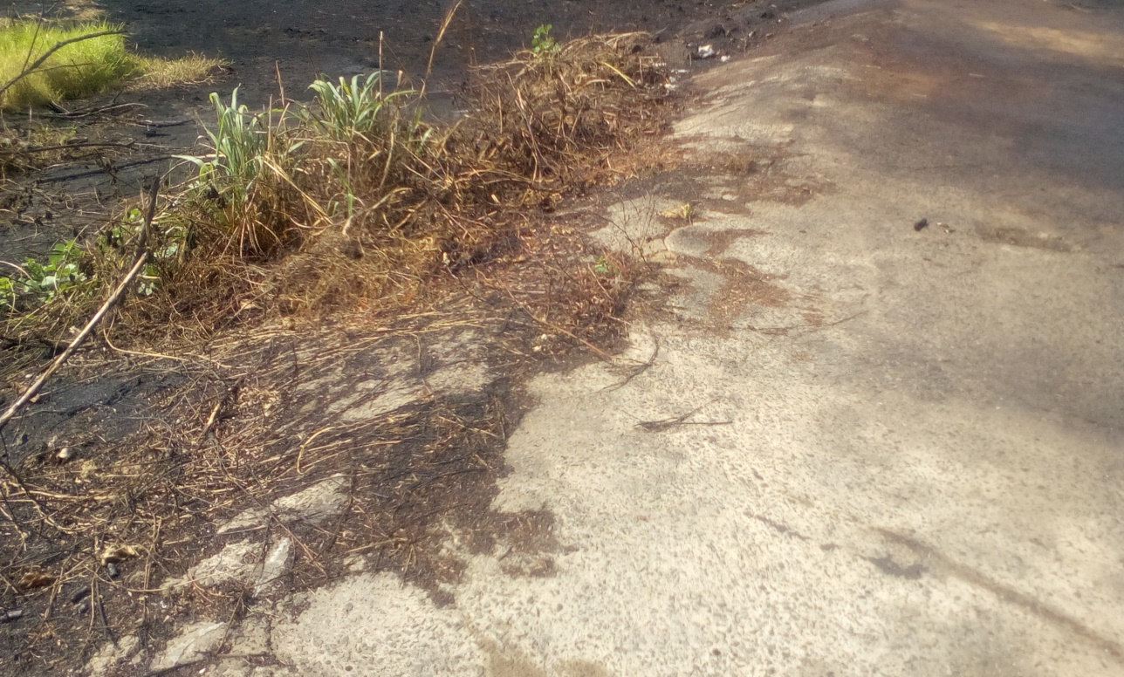
Impacted vegetation by (fire) incident

